XDJ-X
All-in-one DJ system

Exchange protocol
Service commands

 |  |  | Assembly name: | Firmware version:
 |  |  | Display module | 1.01
 |  |  | Mixer assy | 0.41
 |  |  | Deck assy | 0.29
 |  |  | Power manager | 0.27
Last modified date:
04.06.2025

Content
1. Exchange protocols | 3
2. Service commands | 5
3. Utility list | 7

General connection diagram exchange date:
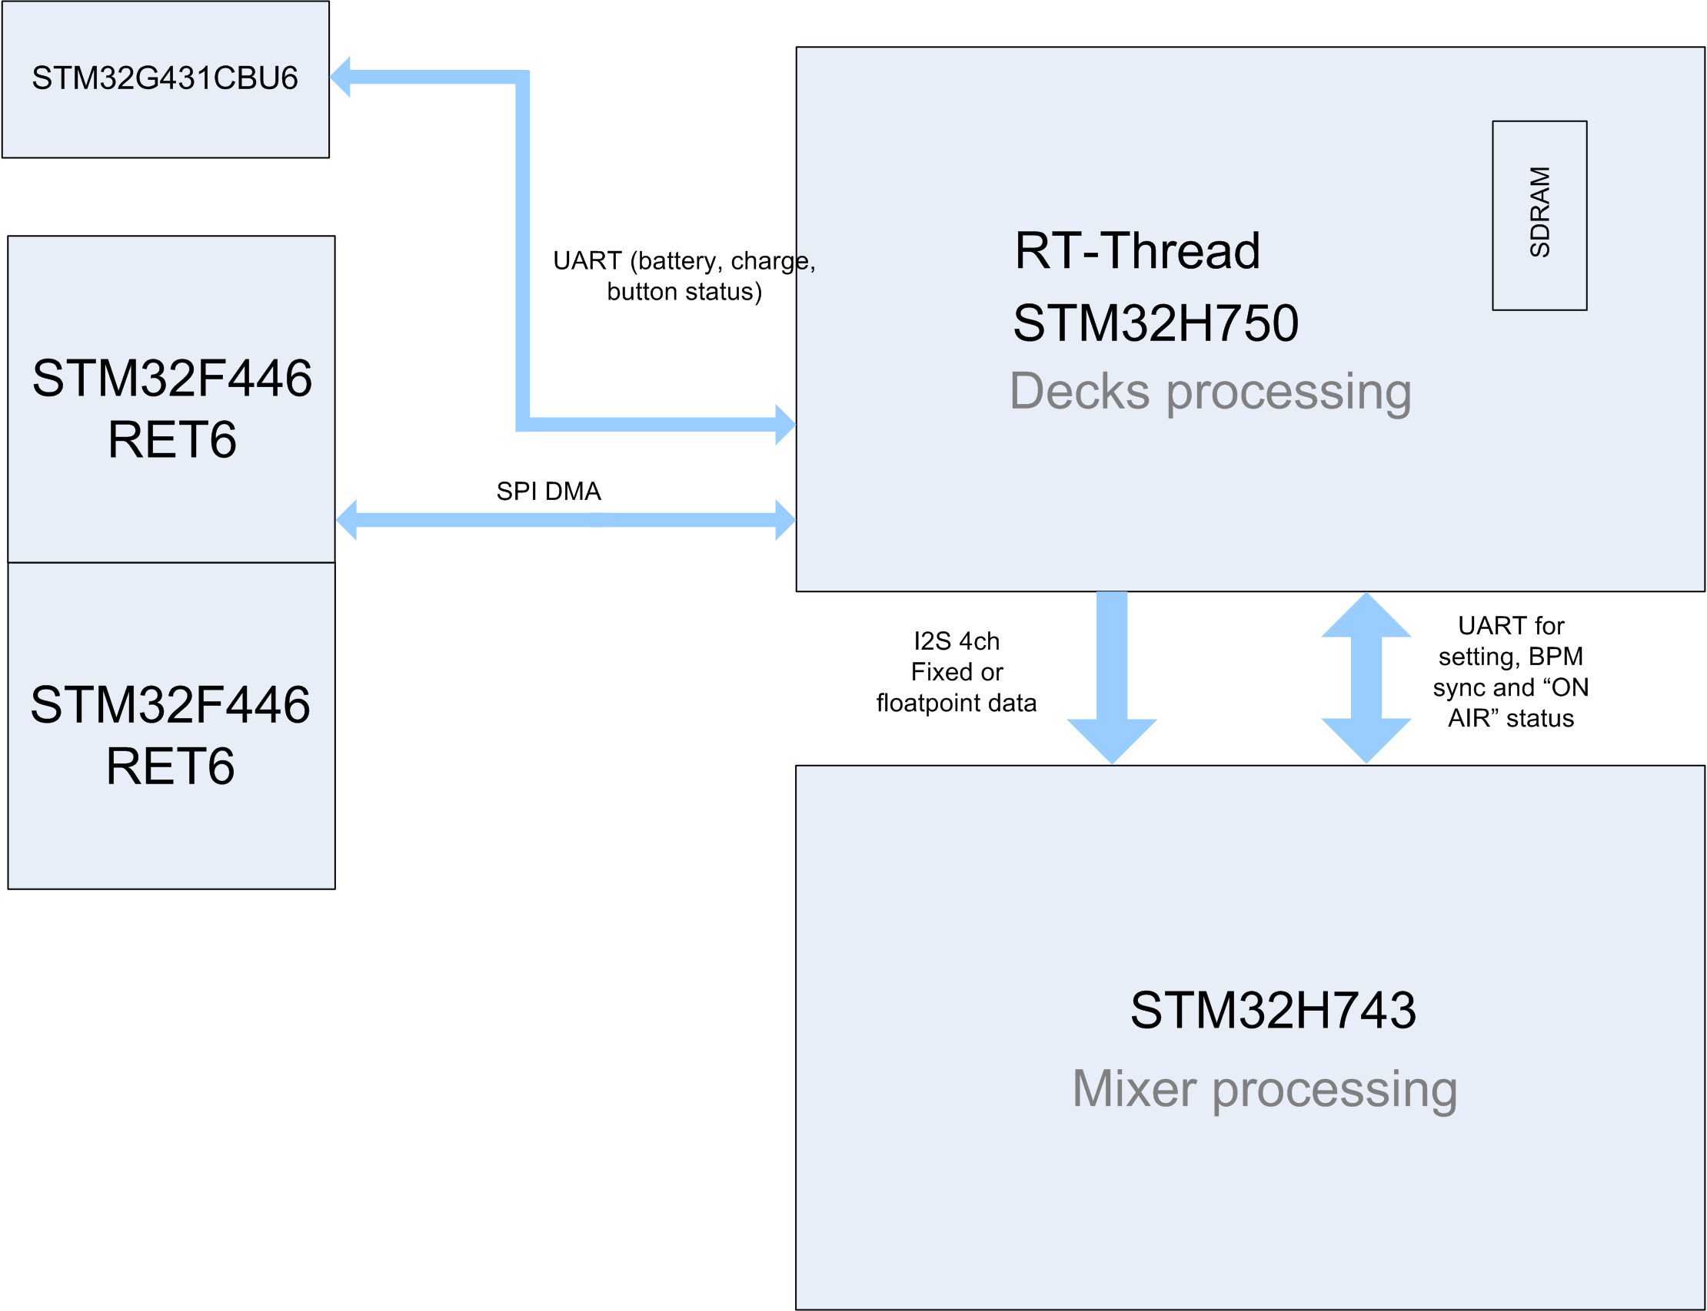

1. Exchange protocols
Display module <=> Power manager
UART transfer 256000 baud.
Power manager => Display module:
 | 0 | 1 | 2 | 3 | 4 | 5 | 6 | 7 | 8 | 9 | A | B | C | D | E | F
Bytes | 0xAX |  |  |  |  |  |  |  | 0xXX
Bits | 1 | 0 | 1 | 0 | 0 | 0 | X | X | X | X | X | X | X | X | X | X

Byte[0] - status:
[0xA1] - no AC
[0xA2] - AC charge
[0xA3] - full battery
Byte[1] - data:
[0xAX][0...100] - charge precentage (when the value changes or on request)
[0xAX][0xFE] - button pressed
[0xAX][0xFD] - button unpressed
[0xAX][0xFC] - shutdown command
[0xAX][1xxxxxxx] – firmware version
Display module => Power manager:
 | 0 | 1 | 2 | 3 | 4 | 5 | 6 | 7 | 8 | 9 | A | B | C | D | E | F
Bytes | 0xA1 |  |  |  |  |  |  |  | 0xXX
Bits | 1 | 0 | 1 | 0 | 0 | 0 | 0 | 1 | X | X | X | X | X | X | X | X

[0xA1][0x01] - firmware version request
[0xA1][0x55] - battery percentage request
[0xA1][0xFC] - shutdown permission

Display module <=> Mixer Assy
UART transfer 256000 baud.
Display module => Mixer Assy:
 | 0 | 1 | 2 | 3 | 4 | 5 | 6 | 7 | 8 | 9 | A | B | C | D | E | F
Bytes | 0x9X |  |  |  |  |  |  |  | 0xXX
Bits | 1 | 0 | 0 | 1 | X | X | X | X | X | X | X | X | X | X | X | X
 | 10 | 11 | 12 | 13 | 14 | 15 | 16 | 17
Bytes | 0xXX
Bits | X | X | X | X | X | X | X | X

[0x91][0x60][0x31] - firmware version request
[0x92][LOW-MID][MID-HIGH] - setting table values ​​of equalizer cutoff frequencies
[0x93][0xB1][FDR] - setting fader curve type
[0x94][0xA3][HDPH] - setting headphones cue type (pre EQ or post EQ)
[0x95-0x96][BPM][BPM] - sending bpm at beats (BPM*100), 0x95-0x96 – first beat 1/4
[0x97][0xFC][0xFC] - shutdown command

Mixer Assy => Display module:
 | 0 | 1 | 2 | 3 | 4 | 5 | 6 | 7 | 8 | 9 | A | B | C | D | E | F
Bytes | 0x9X |  |  |  |  |  |  |  | 0xXX
Bits | 1 | 0 | 0 | 1 | X | X | X | X | X | X | X | X | X | X | X | X
 | 10 | 11 | 12 | 13 | 14 | 15 | 16 | 17
Bytes | 0xXX
Bits | X | X | X | X | X | X | X | X

[0x91][FW][FW] - firmware version (FW*100)
[0x97][DECKA][ [DECKB] – on air status

Display module <=> Deck assy
SPI DMA transfer
Deck assy => Display module:
 | 00 | 01 | 02 | 03 | 04 | 05 |  | 06 | 07 | 08 | 09 | 0A | 0B | 0C | 0D | 0E | 0F
Bytes | PADS |  |  |  |  |  |  |  |  | BUTTONS
Bits | PD7 | PD6 | PD5 | PD4 | PD3 | PD2 |  | PD1 | PD0 | RLP | LP8 | LP4 | VNL | SLIP | REV | CUE | PLAY
 | 10 | 11 | 12 | 13 | 14 | 15 |  | 16 | 17 | 18 | 19 | 1A | 1B | 1C | 1D | 1E | 1F
Bytes | BUTTONS |  |  |  |  |  | ADC_PITCH (10 bits)
Bits | JSNS | TMP | NXT | PREV | RD | 0 |  | P | P | P | P | P | P | P | P | P | P
 | 20 | 21 | 22 | 23 | 24 | 25 |  | 26 | 27 | 28 | 29 | 2A | 2B | 2C | 2D | 2E | 2F
Bytes |  |  |  |  |  |  |  |  |  | JOG_SPEED_MSB
Bits | DIR | FW | FW | FW | FW | FW |  | FW | FW | X | X | X | X | X | X | X | X
 | 30 | 31 | 32 | 33 | 34 | 35 |  | 36 | 37 | 38 | 39 | 3A | 3B | 3C | 3D | 3E | 3F
Bytes | JOG_SPEED_LSB |  |  |  |  |  |  |  |  | CRC
Bits | X | X | X | X | X | X |  | X | X | X | X | X | X | X | X | X | X

ADC_PITCH 0…1023, 512 – center zone
RD – rotation detect
DIR - jog wheel rotation direction
FW – firmware version in code (0-127)
JOG_SPEED 0…65535 16 bits resolution (when jog stopped speed = 0xFFFF)
CRC = (0byte + 1byte +…+6byte)%256
Display module => Deck assy:
 | 00 | 01 | 02 | 03 | 04 | 05 | 06 | 07 | 08 | 09 | 0A | 0B | 0C | 0D | 0E | 0F
Bytes | NUM_P |  |  |  |  |  |  |  | PADn_RED
Bits | RNGr | RNGg | RNGb | LD1 | LD0 | nP | nP | nP | R | R | R | R | R | R | R | R
 | 10 | 11 | 12 | 13 | 14 | 15 | 16 | 17 | 18 | 19 | 1A | 1B | 1C | 1D | 1E | 1F
Bytes | PADn_GREEN |  |  |  |  |  |  |  | PADn_BLUE
Bits | G | G | G | G | G | G | G | G | B | B | B | B | B | B | B | B
 | 20 | 21 | 22 | 23 | 24 | 25 | 26 | 27 | 28 | 29 | 2A | 2B | 2C | 2D | 2E | 2F
Bytes | PLAY_POS |  |  |  |  |  |  |  | SLIP_POS
Bits | X | X | X | X | X | X | X | X | 0 | X | X | X | X | X | X | X
 | 30 | 31 | 32 | 33 | 34 | 35 | 36 | 37 | 38 | 39 | 3A | 3B | 3C | 3D | 3E | 3F
Bytes | CUE_POS |  |  |  |  |  |  |  | CRC
Bits | 0 | X | X | X | X | X | X | X | X | X | X | X | X | X | X | X

nP | LD1 | LD0
0 | CUE | PLAY
1 | SLIP | REV
2 | LP4 | VNL
3 | RLP | LP8
4 | TMP | VNLr
5 | SNSr | MEMr
6 | 0 | 0
7 | 0 | 0

nP - package number and at the same time pad number
PADn_(RED, GREEN, BLUE) RGB 888 color for PAD[NUM_P]
RNGr, RNGg, RNGb – RGB bits <<[NUM_P]
MEMr, SNSr, VNLr – VFD segments
SLIP_POS 0…84. 85 – SLIP disable
CUE_POS 0…84. 85 – CUE without cue on jog display
PLAY_POS 0…134 – jog display position cursor 139 = power on animation 138 = eject animation 137 = load in animation 136 = fill circle on display 135 = empty circle.
CRC = (0byte + 1byte +…+6byte)%256

2. Service commands

3. Utility list

Name: | Array location | EEPROM addr | Parameter list
DECKS
PLAY MODE | [0] | 0x0000 | SINGLE
PLAY MODE | [0] | 0x0000 | CONTINUE
LOAD LOCK | [1] | 0x0001 | LOCK
LOAD LOCK | [1] | 0x0001 | UNLOCK
AUTO CUE MODE | [2] | 0x0002 | -36dB
AUTO CUE MODE | [2] | 0x0002 | -42dB
AUTO CUE MODE | [2] | 0x0002 | -48dB
AUTO CUE MODE | [2] | 0x0002 | -54dB
AUTO CUE MODE | [2] | 0x0002 | -60dB
AUTO CUE MODE | [2] | 0x0002 | -66dB
AUTO CUE MODE | [2] | 0x0002 | -72dB
AUTO CUE MODE | [2] | 0x0002 | -78dB
AUTO CUE MODE | [2] | 0x0002 | MEMORY
AUTO CUE MODE | [2] | 0x0002 | FIRST BEAT
QUANTIZE | [3] | 0x0003 | OFF
QUANTIZE | [3] | 0x0003 | ON
TEMPO RANGE DEFAULT | [4] | 0x0004 | 6%
TEMPO RANGE DEFAULT | [4] | 0x0004 | 10%
TEMPO RANGE DEFAULT | [4] | 0x0004 | 16%
TEMPO RANGE DEFAULT | [4] | 0x0004 | WIDE
COLOR WAVEFORM | [5] | 0x0005 | BLUE
COLOR WAVEFORM | [5] | 0x0005 | RGB
WAVEFORM POSITION | [6] | 0x0006 | CENTER LINE
WAVEFORM POSITION | [6] | 0x0006 | LEFT LINE
JOG ON AIR | [7] | 0x0007 | OFF
JOG ON AIR | [7] | 0x0007 | ON
JOG COLOR ON AIR | [8] | 0x0008 | WHITE
JOG COLOR ON AIR | [8] | 0x0008 | PINK
JOG COLOR ON AIR | [8] | 0x0008 | RED
JOG COLOR ON AIR | [8] | 0x0008 | ORANGE
JOG COLOR ON AIR | [8] | 0x0008 | YELLOW
JOG COLOR ON AIR | [8] | 0x0008 | GREEN
JOG COLOR ON AIR | [8] | 0x0008 | AQUA
JOG COLOR ON AIR | [8] | 0x0008 | BLUE
JOG COLOR ON AIR | [8] | 0x0008 | PURPLE
JOG COLOR ON AIR | [8] | 0x0008 | TRACK COLOR
JOG COLOR INACTIVE | [9] | 0x0009 | WHITE
JOG COLOR INACTIVE | [9] | 0x0009 | PINK
JOG COLOR INACTIVE | [9] | 0x0009 | RED
JOG COLOR INACTIVE | [9] | 0x0009 | ORANGE
JOG COLOR INACTIVE | [9] | 0x0009 | YELLOW
JOG COLOR INACTIVE | [9] | 0x0009 | GREEN
JOG COLOR INACTIVE | [9] | 0x0009 | AQUA
JOG COLOR INACTIVE | [9] | 0x0009 | BLUE
JOG COLOR INACTIVE | [9] | 0x0009 | PURPLE
JOG COLOR INACTIVE | [9] | 0x0009 | TRACK COLOR
JOG BRIGHTNESS | [10] | 0x000A | 1
JOG BRIGHTNESS | [10] | 0x000A | 2
LCD BRIGHTNESS | [11] | 0x000B | 1
LCD BRIGHTNESS | [11] | 0x000B | 2
LCD BRIGHTNESS | [11] | 0x000B | 3
LCD BRIGHTNESS | [11] | 0x000B | 4
LCD BRIGHTNESS | [11] | 0x000B | 5
PADS MODE | [12] | 0x000C | NORMAL
PADS MODE | [12] | 0x000C | GATE
MIXER
FADER CURVE | [13] | 0x000D | LINEAR
FADER CURVE | [13] | 0x000D | SLOW
SPEAKERS | - |  | OFF
SPEAKERS | - |  | ON
EQ frequency LOW-MID | [14] | 0x000E
EQ frequency MID -HIGH | [15] | 0x000F
HEADPHONES CUE | [16] | 0x0010 | PRE EQ
HEADPHONES CUE | [16] | 0x0010 | POST EQ
GENERAL
BATT. INFO | -
VERSION No.
DECK 1 | - |  | 0.29
DECK 2 | - |  | 0.29
MAIN ASSY | - |  | 1.03
MIXER ASSY |  |  | 0.41
POWER MANAGER | - |  | 0.27
DEVELOPER | - |  | ANATSKA ANDREI

